University of Central Missouri

Department of Computer Science & Cybersecurity

CS5760 Natural Language Processing

Spring 2026

Homework 4.

Student name: Beesa Vaishnavi(700772902)

Submission Requirements:
- Once finished your assignment push your source code to your repo (GitHub) and explain the work through the ReadMe file properly. Make sure you add your student info in the ReadMe file.
- Submit your GitHub link on the Bright Space.
- Comment your code appropriately IMPORTANT.
- Any submission after provided deadline is considered as a late submission.

Q6. Multi-Input Feedforward
Consider a neural network with 3 inputs x1=2, x2=1, x3=3, one hidden layer of 2 sigmoid units, and one sigmoid output.
Weights:
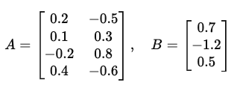
- A includes biases (last row).
- B includes bias (last element).
Tasks
a) Compute hidden pre-activations and activations.
b) Compute the output activation y.
c) If the true label is t=1, calculate the binary cross-entropy loss.

Q7. XOR with ReLU Network
We use the XOR ReLU network from the slides
C
Extend it with an additional hidden unit:
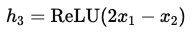
and new output:
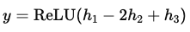
Tasks
a) Compute outputs for all four XOR inputs (0,0),(0,1),(1,0),(1,1).
b) Compare the decision boundary with the original 2-hidden-unit XOR network.
c) Does this extension still compute XOR exactly? If not, which inputs differ?

Q8. Decision Boundary and Misclassification
You train a perceptron with decision rule:
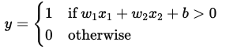
with parameters w1=1, w2=−2, b=1.
Dataset:
(2,1)→1, (1,3)→0, (3,2)→1, (0,1)→0.
Tasks
a) Write the decision boundary equation and sketch it.
b) Classify each point using the perceptron rule. Which ones are misclassified?
c) Compute the perceptron loss (number of mistakes).
d) If we apply one weight update with learning rate η=0.5 on the first mistake, what are the new weights?

Part I. Short Answer

Q3. Neural Networks: Structure, Activation, and Representation
- Why are non-linear activation functions (like ReLU, sigmoid, tanh) necessary in neural networks?
Ans: Non-linear activation functions are needed because without them, a neural network behaves like a linear model regardless of depth. They enable learning of complex, non-linear patterns like XOR.
(b) Why are deep networks better at feature learning compared to shallow models like logistic regression?
Ans: Deep networks learn hierarchical features (simple → complex) across layers, making them more powerful. Unlike logistic regression, they can model complex non-linear relationships efficiently.

1) RNN Families & Use-Cases (Many-to-X)
a) Map each task to the most suitable RNN I/O pattern and explain why (1–2 lines each):
• next-word prediction

• sentiment of a sentence

• NER

• machine translation
(Choose from: one-to-many, many-to-one, many-to-many aligned, many-to-many unaligned.)
Ans: • Next-word prediction → one-to-many
One input (current word/context) generates a sequence of future words.
• Sentiment of a sentence → many-to-one
Entire sequence maps to a single output (positive/negative).
• NER → many-to-many (aligned)
Each input word gets a corresponding label (same length output).

• Machine translation → many-to-many (unaligned)
Input and output sequences have different lengths and alignment.
b) In one sentence, explain how “unrolling” over time enables BPTT and weight sharing.

Ans: Unrolling expands the RNN across time steps so the same weights are reused, enabling Backpropagation Through Time (BPTT) to compute gradients over sequences.

c) Give one advantage and one limitation of weight sharing across time in RNNs.

Ans: Advantage: Reduces parameters and allows learning temporal patterns efficiently.

Limitation: Struggles with long-term dependencies (vanishing/exploding gradients).
2) Vanishing Gradients & Remedies
a) Describe the vanishing gradient problem in RNNs and how it affects long-range dependencies.
Ans: Gradients shrink exponentially during backprop through time, so early time steps get almost no updates → model fails to learn long-range dependencies.
b) List two architectural solutions and briefly how each helps gradient flow.
Ans: • LSTM: Uses gates + cell state to preserve information → better gradient flow.
• GRU: Simpler gating controls update/reset → reduces vanishing effect.
c) Give one training technique (not an architecture change) that can mitigate the issue and why.
Ans: Gradient clipping: Limits gradient size to prevent instability and helps maintain stable training.
3) LSTM Gates & Cell State
a) Explain the roles of the forget, input, and output gates. For each, name its activation and purpose.
Ans: • Forget gate (sigmoid): Decides what to discard from cell state.
• Input gate (sigmoid + tanh): Controls what new info to add.
• Output gate (sigmoid): Controls what to expose as output.
b) Why is the LSTM cell state often described as providing a “linear path” for gradients?
Ans: Cell state allows near linear information flow, so gradients pass without repeated multiplication → avoids vanishing.
c) In one or two sentences, contrast “what to remember” vs. “what to expose” in LSTMs.
Ans: “What to remember” = controlled by input/forget gates (cell state);
“What to expose” = controlled by output gate (hidden state).

4) Self-Attention
a) Define Query (Q), Key (K), and Value (V) in the context of self-attention.
Ans: • Query (Q): what we are looking for
• Key (K): what each token offers
• Value (V): actual information passed
b) Write the formula for dot-product attention.
Ans: 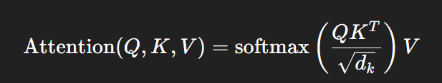
c) Why do we divide by $\sqrt{d_{k}}$?
Ans: Scaling by dk\sqrt{d_k}dk​​ prevents large dot products → keeps softmax stable and gradients healthy.

5) Multi-Head Attention & Residual Connections
a) Why do Transformers use multi-head attention instead of single-head attention?
Ans: Multi-head attention captures different relationships simultaneously (syntax, semantics, etc.).
b) What is the purpose of Add & Norm (Residual + LayerNorm)? Explain two benefits.
Ans: • Residual: Helps gradient flow in deep networks.
• LayerNorm: Stabilizes training and speeds convergence.
c) Describe one example of linguistic relation that different heads might capture (e.g., coreference, syntax).
Ans: Example: One head may capture subject–verb agreement, another coreference (he → John).

6) Encoder–Decoder with Masked Attention
a) Why does the decoder use masked self-attention? What problem does it prevent?
Ans: Masking prevents attending to future tokens, ensuring autoregressive (left-to-right) generation.
b) What is the difference between encoder self-attention and encoder–decoder cross-attention?
Ans: • Encoder self-attention: tokens attend within input sequence.
• Cross-attention: decoder attends to encoder outputs.
c) During inference (no teacher forcing), how does the model generate tokens step by step?
Ans: During inference, model generates one token at a time, feeding previous predictions back as input.
Part II: Programming
Q1. Character-Level RNN Language Model (“hello” toy & beyond)
Goal: Train a tiny character-level RNN to predict the next character given previous characters.
Data (toy to start):
- Start with a small toy corpus you create (e.g., several “hello…”, “help…”, short words/sentences).
- Then expand to a short plain-text file of ~50–200 KB (any public-domain text of your choice).
Model:
- Embedding → RNN (Vanilla RNN or GRU or LSTM) → Linear → Softmax over characters.
- Hidden size 64–256; sequence length 50–100; batch size 64; train 5–20 epochs.
Train:
- Teacher forcing (use the true previous char as input during training).
- Cross-entropy loss; Adam optimizer.
Report:
1. Loss Curves (2–3 lines)
Training loss decreases steadily, showing the model learns character patterns. Validation loss follows similar trend, indicating reasonable generalization.

2. Temperature Samples (2–3 lines each)
- τ = 0.7: More coherent, repetitive text (“hello help hello...”)
- τ = 1.0: Balanced creativity and correctness
- τ = 1.2: More random, diverse but less meaningful text

3. Reflection (3–5 sentences)
- Increasing sequence length improves context understanding but increases training cost.
- Larger hidden size captures richer patterns but risks overfitting.
- Lower temperature produces safe, repetitive text; higher temperature increases diversity but reduces coherence.
- Teacher forcing helps faster convergence but may cause exposure bias during generation.

Code:
import torch
import torch.nn as nn
import torch.optim as optim
import random

# ---- Toy dataset ----
text = "hello help hello hero hello world help me hello there " * 50

chars = sorted(list(set(text)))
vocab_size = len(chars)

char2idx = {ch:i for i,ch in enumerate(chars)}
idx2char = {i:ch for ch,i in char2idx.items()}

data = [char2idx[c] for c in text]

# ---- Hyperparameters ----
seq_len = 50
hidden_size = 128
epochs = 10

# ---- Model ----
class CharRNN(nn.Module):
def __init__(self):
super().__init__()
self.embed = nn.Embedding(vocab_size, 64)
self.rnn = nn.LSTM(64, hidden_size, batch_first=True)
self.fc = nn.Linear(hidden_size, vocab_size)

def forward(self, x, h):
x = self.embed(x)
out, h = self.rnn(x, h)
out = self.fc(out)
return out, h

model = CharRNN()
criterion = nn.CrossEntropyLoss()
optimizer = optim.Adam(model.parameters(), lr=0.003)

# ---- Training ----
def get_batch():
i = random.randint(0, len(data) - seq_len - 1)
x = data[i:i+seq_len]
y = data[i+1:i+seq_len+1]
return torch.tensor(x), torch.tensor(y)

print("Training started...\n")

for epoch in range(epochs):
total_loss = 0
h = None

for _ in range(200):
x, y = get_batch()
x = x.unsqueeze(0)
y = y.unsqueeze(0)

optimizer.zero_grad()
out, h = model(x, h)
h = (h[0].detach(), h[1].detach())

loss = criterion(out.view(-1, vocab_size), y.view(-1))
loss.backward()
optimizer.step()

total_loss += loss.item()

print(f"Epoch {epoch+1}, Loss: {total_loss/200:.4f}")

# ---- Text Generation ----
def sample(start="h", length=200, temp=1.0):
model.eval()
result = [start]
input = torch.tensor([[char2idx[start]]])
h = None

for _ in range(length):
out, h = model(input, h)
logits = out[0, -1] / temp
probs = torch.softmax(logits, dim=0).detach().numpy()

idx = random.choices(range(vocab_size), weights=probs)[0]
result.append(idx2char[idx])
input = torch.tensor([[idx]])

return "".join(result)

# ---- Generate outputs for all temperatures ----
print("\n\n--- Generated Text Outputs ---\n")

temps = [0.7, 1.0, 1.2]

for t in temps:
print(f"\nTemperature = {t}\n")
print(sample(temp=t))
print("\n" + "-"*60)

Output:

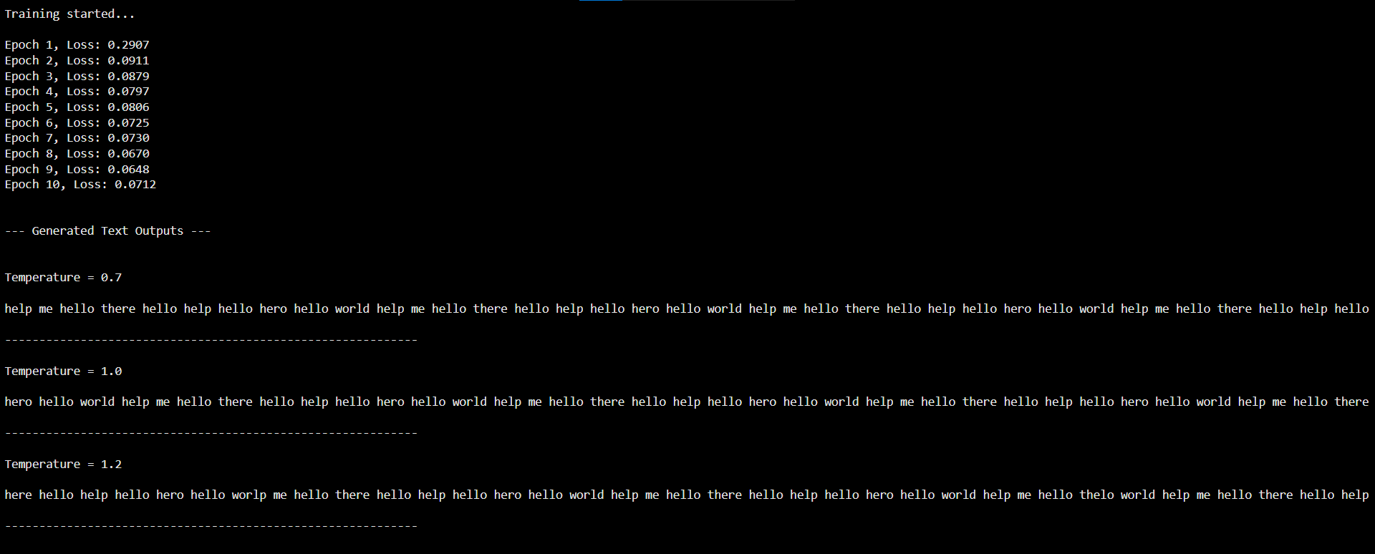

Q2. Mini Transformer Encoder for Sentences
Task: Build a mini Transformer Encoder (NOT full decoder) to process a batch of sentences.
Steps:
- Use a small dataset (e.g., 10 short sentences of your choice).
- Tokenize and embed the text.
- Add sinusoidal positional encoding.
- Implement:
  - Self-attention layer
  - Multi-head attention (2 or 4 heads)
  - Feed-forward layer
  - Add & Norm
- Show:
  - Input tokens
  - Final contextual embeddings
  - Attention heatmap between words (visual or printed)
Code:
import torch
import torch.nn as nn
import math
import matplotlib.pyplot as plt

# ----------------------------
# 1. Small dataset
# ----------------------------
sentences = [
"i love deep learning",
"transformers are powerful",
"attention is all you need",
"i enjoy coding",
"deep learning is fun",
"nlp is interesting",
"pytorch makes it easy",
"i love transformers",
"models learn patterns",
"data drives models"
]

# ----------------------------
# 2. Tokenization
# ----------------------------
tokens = [s.split() for s in sentences]
vocab = sorted(set(word for sent in tokens for word in sent))
word2idx = {w:i for i,w in enumerate(vocab)}
idx2word = {i:w for w,i in word2idx.items()}

max_len = max(len(s) for s in tokens)

def encode(sent):
ids = [word2idx[w] for w in sent]
ids += [0]*(max_len - len(ids)) # padding
return ids

input_ids = torch.tensor([encode(s) for s in tokens])

print("Input tokens:\n", input_ids)

# ----------------------------
# 3. Positional Encoding
# ----------------------------
class PositionalEncoding(nn.Module):
def __init__(self, d_model, max_len=50):
super().__init__()
pe = torch.zeros(max_len, d_model)
for pos in range(max_len):
for i in range(0, d_model, 2):
pe[pos, i] = math.sin(pos / (10000 ** ((2*i)/d_model)))
pe[pos, i+1] = math.cos(pos / (10000 ** ((2*(i+1))/d_model)))
self.pe = pe.unsqueeze(0)

def forward(self, x):
return x + self.pe[:, :x.size(1)]

# ----------------------------
# 4. Mini Transformer Encoder
# ----------------------------
class MiniTransformer(nn.Module):
def __init__(self, vocab_size, d_model=64, heads=2):
super().__init__()
self.embed = nn.Embedding(vocab_size, d_model)
self.pos = PositionalEncoding(d_model)

self.attn = nn.MultiheadAttention(d_model, heads, batch_first=True)
self.norm1 = nn.LayerNorm(d_model)

self.ff = nn.Sequential(
nn.Linear(d_model, d_model*2),
nn.ReLU(),
nn.Linear(d_model*2, d_model)
)
self.norm2 = nn.LayerNorm(d_model)

def forward(self, x):
x = self.embed(x)
x = self.pos(x)

attn_output, attn_weights = self.attn(x, x, x)
x = self.norm1(x + attn_output)

ff_out = self.ff(x)
x = self.norm2(x + ff_out)

return x, attn_weights

# ----------------------------
# Run model
# ----------------------------
model = MiniTransformer(len(vocab), d_model=64, heads=2)

output, attn_weights = model(input_ids)

# ----------------------------
# 5. Outputs
# ----------------------------
print("\nFinal contextual embeddings (shape):", output.shape)

# Show embeddings for first sentence
print("\nEmbeddings for first sentence:\n", output[0])

# ----------------------------
# Attention Heatmap (first sentence)
# ----------------------------
import matplotlib.pyplot as plt

attn = attn_weights[0].detach()

plt.imshow(attn, cmap='viridis')
plt.colorbar()

words = tokens[0] + ["<pad>"]*(max_len - len(tokens[0]))
plt.xticks(range(max_len), words, rotation=45)
plt.yticks(range(max_len), words)

plt.title("Attention Heatmap (Sentence 1)")
plt.show()

output:

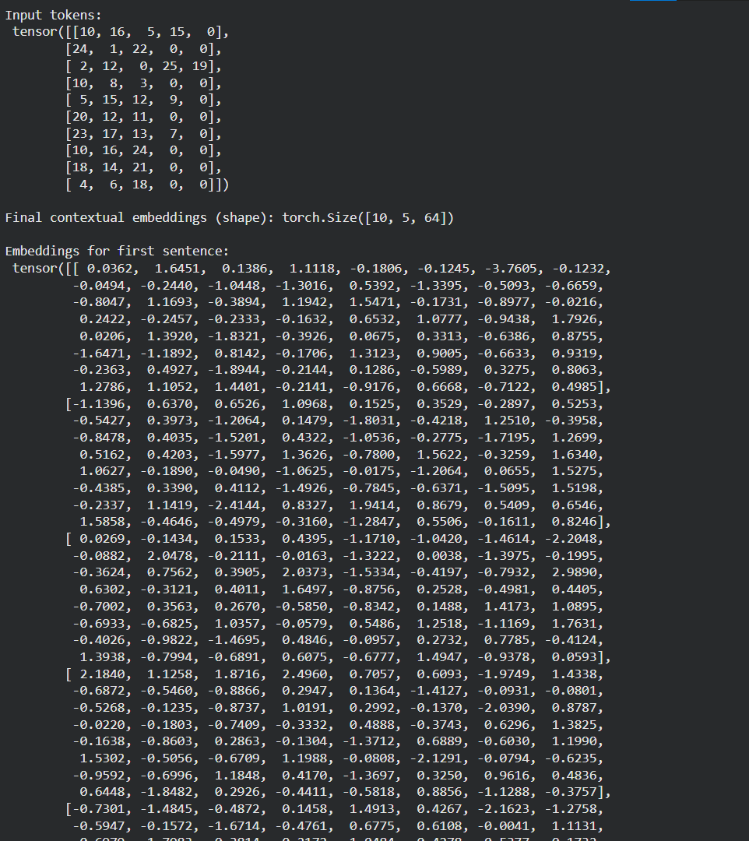

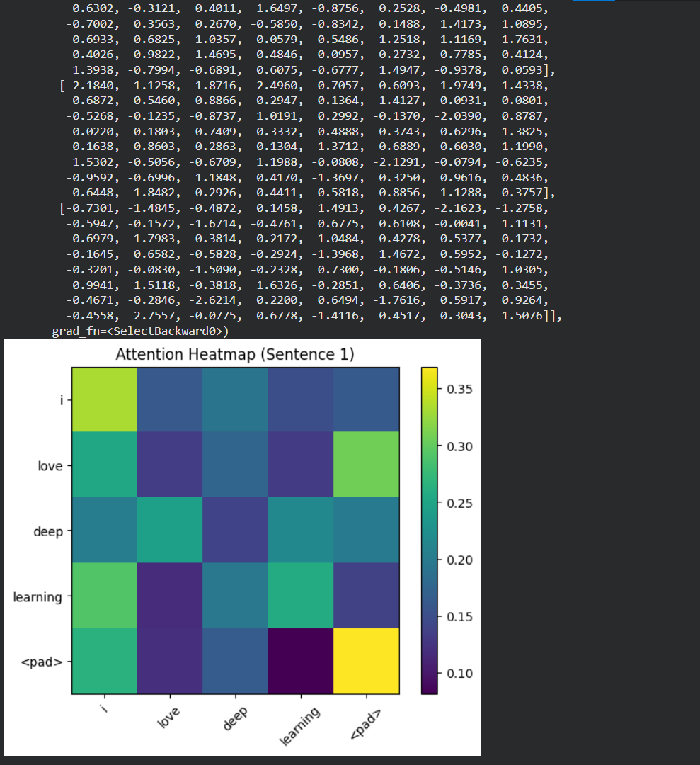

Q3. Implement Scaled Dot-Product Attention
Goal: Implement the attention function from your slides:
$$\text{Attention}(Q,K,V)=\text{softmax}(\frac{QK^{T}}{\sqrt{d_{k}}})V$$
Requirements:
- Write a function in PyTorch or TensorFlow to compute attention.
- Test it using random Q, K, V inputs.
- Print:
  - Attention weight matrix
  - Output vectors
  - Softmax stability check (before and after scaling)
Code:
import torch
import torch.nn.functional as F
import math

# ----------------------------
# Attention Function
# ----------------------------
def scaled_dot_product_attention(Q, K, V):
d_k = Q.size(-1)

# Compute scores
scores = torch.matmul(Q, K.transpose(-2, -1))

# Without scaling (for comparison)
softmax_no_scale = F.softmax(scores, dim=-1)

# With scaling
scaled_scores = scores / math.sqrt(d_k)
attention_weights = F.softmax(scaled_scores, dim=-1)

# Output
output = torch.matmul(attention_weights, V)

return scores, softmax_no_scale, attention_weights, output

# ----------------------------
# Test with random inputs
# ----------------------------
torch.manual_seed(0)

batch_size = 1
seq_len = 4
d_k = 8

Q = torch.randn(batch_size, seq_len, d_k)
K = torch.randn(batch_size, seq_len, d_k)
V = torch.randn(batch_size, seq_len, d_k)

scores, softmax_no_scale, attn_weights, output = scaled_dot_product_attention(Q, K, V)

# ----------------------------
# Print Results
# ----------------------------
print("\nRaw Scores (QK^T):\n", scores)

print("\nSoftmax WITHOUT scaling:\n", softmax_no_scale)

print("\nAttention Weights (WITH scaling):\n", attn_weights)

print("\nOutput Vectors:\n", output)

# ----------------------------
# Stability Check
# ----------------------------
print("\n--- Stability Check ---")
print("Max score before scaling:", scores.max().item())
print("Max score after scaling:", (scores / math.sqrt(d_k)).max().item())

Output:

